# Lab 11: Blackbody Radiation

Alia binti Mohd Zaki

4/17/2020

**1. Figure and Tables**

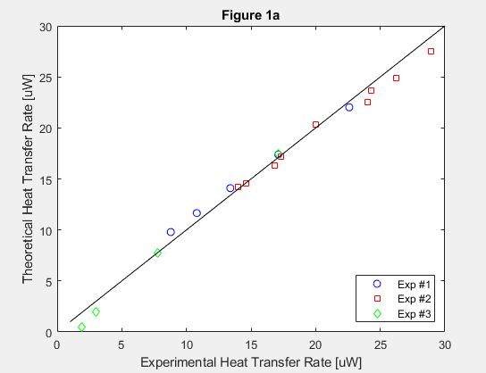

**Figure 1a.** Plot of the experiment heat transfer rate versus the theoretical heat transfer rate. The solid line is a 1:1 line to determine the agreement between the experimental and theoretical values.

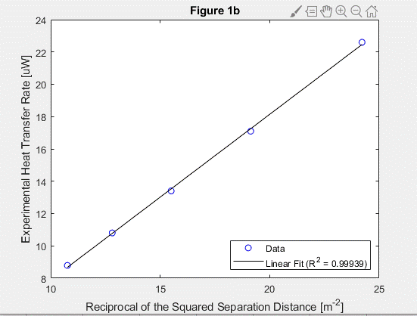

**Figure 1b.** Plot of the reciprocal of the squared separation distance $1/h^{2}$ versus the experimental heat transfer rate. The solid black line represents the linear regression between the two variables.

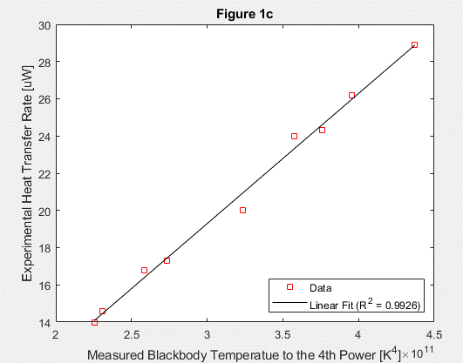

**Figure 1c.** Plot of the measured blackbody temperature to the 4th power versus the experimental heat transfer rate. The solid black line represents the linear regression between the two variables.

**Figure 1d.** Plot of the squared diameter of the aperture $D^{2}$ versus the experimental heat transfer rate. The solid black line represents the linear regression between the two variables.

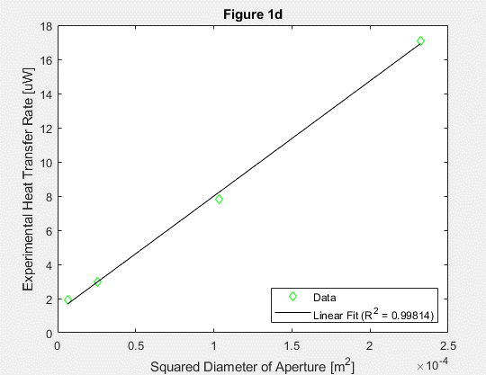

**2. Short Answer Questions**

1. *Quantify the agreement in q between the measurements and theory based on your results in plot 1a. State your answer in terms of an average percent relative difference, , according to the following relationship = 1 N X N i=1 |qidata − qitheory | qitheory · 100% , (18) where N is the total number of data points acquired (over all four experiments). Comment on whether the discrepancy between the measurements and theory seem to be random across the entire q range investigated, or whether there are particular q ranges where the agreement appears better/worse. [2–4 sentences]*

The average percent relative difference is 0.7829%, 0.4070%, and 0.6239% respectively for experiments #1, #2. and #3. The discrepancy between the measuremtns and theory do not seem to be random at all across the entire q range investigated as the percentage differences are <1%. The agreement appears the best when T is varied and the “worst” when h is varied. Keep in mind that the “worst” is still very accurate in my almost graduated engineering opinion.

1. *Given your results in plots in 1a–1d, including your calculated R2 values for the curve fits, and using your engineering judgment, assess whether the theory adequately supports the measurements, in terms of the expected dependence of q on T, h, and D. Be specific in your explanation of why or why not. [2–3 sentences]*

Based on the calculated $R^{2}$ values, the theory that the experimental heat transfer rate is linearly proportional to 1/ $h^{2}$, and $D^{2}$ is accurate. The $R^{2}$ values are 0.9994, 0.9926, and 0.9981 respectively for experiments 1, 2, and 3 proving the high accuracy of the theoretical values. It has also been proved in 2a) that the theoretical data agrees with the experimental data since the percent differences are <1%.

1. *Assume now that the blackbody cavity in the experiment is replaced with a diffuse “gray body”, whose surface temperature can be adjusted uniformly with a heater and thermostat, in a manner similar to what was done in the actual experiment. Describe how you would modify the experimental procedures and/or data analysis in order to determine the unknown emissivity ε of the “gray body”. [2–4 sentences]*

To determine the unknown emissivity of the gray body, the heat transfer rates from both the “gray body” and blackbody cavities should be measured using the pyroelectric radiometer. The heat transfer rate measured from the “gray body” is divided by the heat transfer rate by the blackbody, resulting in the emissivity of the gray body.